Redox Notes

* Redox involves transfer of electrons
* **Oxidised ⇒ loses electrons**
* **Reductions ⇒ gains electrons**
* **Reduced species ⇒ oxidising agent/oxidant**
* **Oxidised species ⇒ reducing agent/reductant**
* Redox reaction only occurs if there is a transfer of electrons
* Oxidation numbers shows which atoms are reduced or oxidised

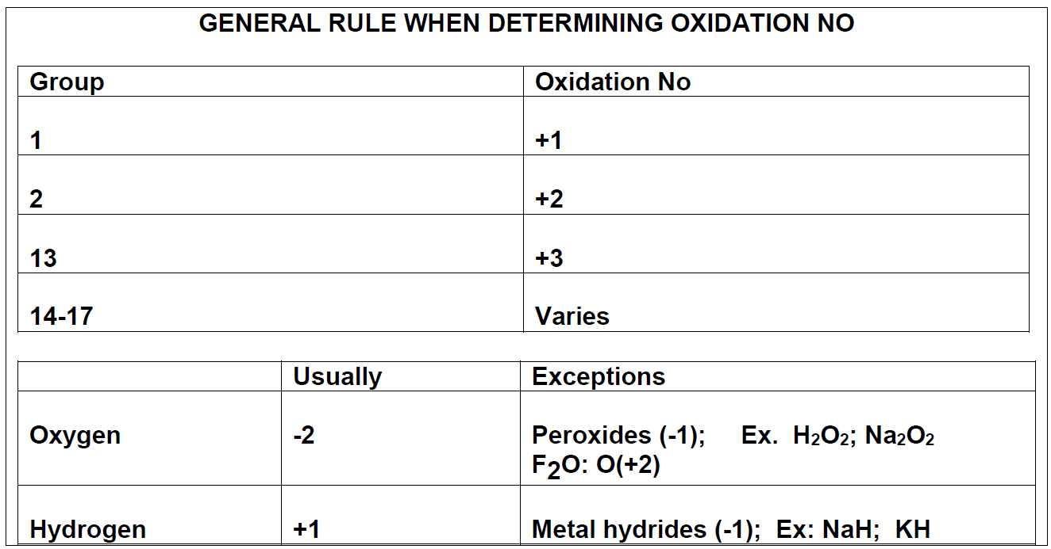

* Sum of oxidation numbers = net charge
* Oxidised species increase in oxidation number
* Reduced species decrease in oxidation number (reduced ⇒ become smaller)
* Species which do not change in oxidisation numbers are spectators

# Types of Redox Reactions

* Metal-metal ion displacement ⇒ electrons transfer from more reactive metal to less reactive metal ions (more reactive metal is oxidised, less reactive reduced)
* Halogen-halide ion displacement ⇒ halogen (group 17) becomes reduced, halide ions of less reactive halogen oxidised
  + It is more convenient to use halogen reagents in aqueous solution form
* Combustion ⇒ oxidisation of fuel and reduction of oxygen gas
* Corrosion ⇒ Metal is oxidised, and oxygen gas is reduced
  + More reactive metals have greater tendency to corrode
  + Some metals naturally form a thin protective oxide coating which forms when exposed to air, hence protecting underlying metal from corrosion

# Half Equations

* Half equations show individual reactions of oxidised and reduced species
* Oxidisation half equations have electrons as product
* Reduced half equations have electrons as reactant
* When both half equations are combined, electrons cancel out and redox reaction is remaining

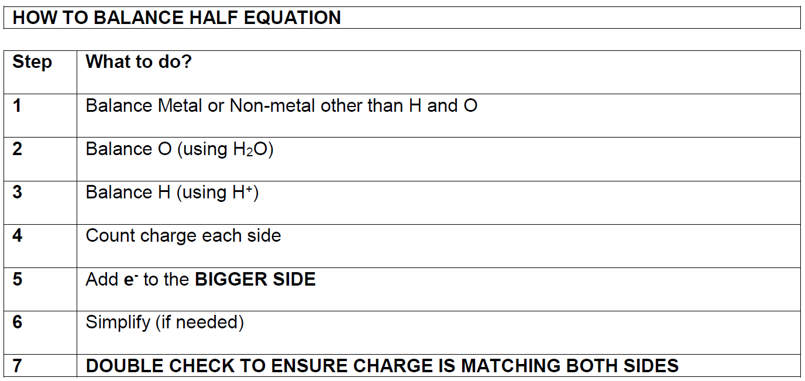

* In simply stage, if H2O or H+ are on both sides, subtract coefficient on both sides by smallest number

# Predicting Spontaneity

* Total E0 can be used to predict spontaneity
* If E0>0, reaction is spontaneous => reaction will only occur in forward direction
* If E0<0, reaction is not spontaneous => reaction will only occur in reverse direction

# Galvanic Cells

* Galvanic cells/electrochemical cells ⇒ batteries
* Galvanic cells use redox reaction to produce a voltage (potential difference) and current
* They work by allowing redox reaction to occur without direct contact between agents
* **Anode ⇒ loses electrons/oxidised/reducing agent**
* **Cathode ⇒ gains electrons/reduced/oxidising agent**
* Galvanic cell uses metal cathode and anode in aqueous solution (reducing and oxidising agents) of respective ions of metals
* Anodes and cathodes are connected, and salt bridge made of non-reactive electrolyte solution connects solutions

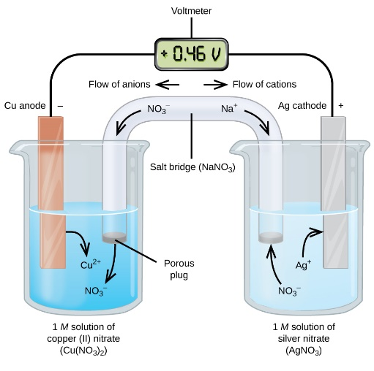

* Anode ⇒ oxidisation occurs. Electrode contacts reductant and labelled -ve terminal
* Cathode ⇒ reduction occurs. Electrode contacts oxidant and labelled +ve terminal
* Electrolyte ⇒ electrodes (metal nodes) are immersed in electrolyte solution
  + Ions in electrolyte conduct charge in the solution to prevent build-up of charge
  + May become oxidised or reduced
* Salt Bridge ⇒ contains a non-reactive electrolyte solution
  + Prevents direct contact between redox agents, while allowing ions to flow between them
  + Anions flow towards anode
  + Cations flow towards cathode
  + Salt bridge is essential to prevent build-up of electrical charge
  + If no salt bridge, there will be no potential difference in charge between nodes, therefore, no current
* Oxidation half-cell ⇒ where oxidation occurs
  + Consists of anode and surrounding electrolyte
* Reduction half-cell ⇒ where reduction occurs
  + Consists of cathode and surrounding electrolyte

## Strength of Oxidants

* Voltage is a measure of strength of oxidant
* Back of data sheet (table of standard reduction potentials) ranks strength of oxidising agents
* SRP is ability of a substance to be reduced by H2 gas
* Test is same as galvanic cell, but hydrogen gas node in H+ electrolyte is used against tested substance
* Therefore, voltage produced against hydrogen as tested substance is 0V, as no potential difference exists
* SRPT shows potential for reaction to occur
* Equations at bottom of the table are least likely to occur

## Predicting Equations

* Do determine if a reaction will occur and spontaneity, look at SRPT
* SRPT half equations are ranking in order of ability to be reduced
* Substances at the top of the table have a higher electronegativity and are good oxidants
* Substances at the bottom have a low electronegativity and are good reductants
* Each half equation is reversable
* Left ⇒ right is reduction
* Right ⇒ left is oxidation
* All reduction potentials are relative to hydrogen ions
* Do not use values in explanations, unless comparing two half equations
* Predicting:

1. List all species on reactant side of the potential reaction ⇒ don’t list products
2. Species which appears first from the top is oxidising agent
3. Species which appears second from the top is reducing agent
4. Ignore all other species

* If oxidant is above reductant, reaction is spontaneous, otherwise, there’s no reaction
* Negative slope ⇒ reaction occurs
* Positive slope ⇒ no reaction occurs
* If half equation is not on the chart, spontaneity cannot be predicted unless further information is not provided
* Non-chart equations ⇒ ranks equations from information given
* Phases:
  + Ensure phases in questions are phases being used ⇒ not phases in chart
  + RTQ to ensure correct phases
* All reactions in SRPT is at standard conditions ⇒ 25o, 1.00M and 1atm
  + Predictions become unreliable if not at these conditions

# Fuel Cells

* Primary Cells
  + Non rechargeable galvanic cells
  + Fixed amount of oxidants and reductants (fixed amount of reactant) and cannot be replaced
  + Alkaline cells => devices that require higher current (cd players, torches, radios etc)
  + Silver oxide button cells =>steady constant voltage and small size (watches, pacemakers, hearing aids)
  + Lithium cell =>very flammable, non-toxic and high energy density
  + Dry Cell
    - Advantages:
      * Cheap
      * Portable
    - Disadvantages:
      * Low energy to mass ratio
      * Voltage decreases slowly over time (due to disintegration of reactants)
      * Max V = 1.5V, however this decreases with time ([reactants] decrease)
      * Large quantities of toxic Zn waste may enter groundwater and soil in disposal in landfill
    - Can be attached in series to add voltage

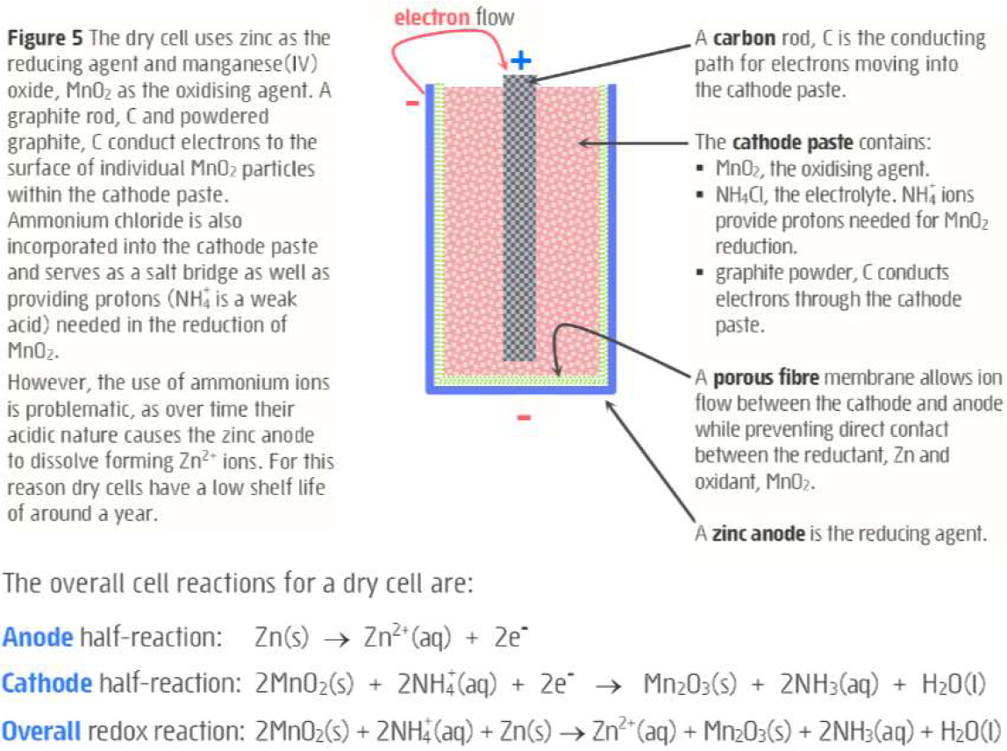

* Secondary Cells
  + Rechargeable galvanic cells
  + Lead-acid cell

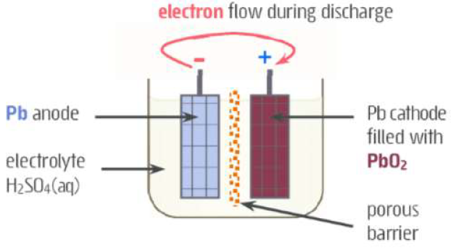

* + - Each cell produces 2V and are connected in series
    - Used in vehicles, solar power systems and emergency power systems
    - Recharging lead acid battery is essentially electrolysis, DC current applied in opposite direction to force oxidant and reductant to reform
    - Two lead grid electrodes immersed in sulfuric acid
      * Anode grid has spongy lead (Pb)
      * Cathode has powdered lead oxide (PbO2)
    - Discharge:
      * Pb oxidised to PbSO4 in presence of H2SO4
      * PbO2 solid reduced in presence of H2SO4
    - Recharge:
      * Other direction (anode becomes positive, cathode becomes negative)
      * Current is applied such that Voltage>2V to ensure completion of reaction
      * Net Voltage>0V
      * Reverse discharge reaction
    - Advantages
      * High surge current =>cells maintain high power to weight ratio
      * Powdered lead components =>greater surface area and reaction rate
      * Low cost
      * Can undergo many discharge/recharge cycles over many years
      * Flat =>force DC current in opposite direction for spontaneous reaction and recharge
  + Lithium Ion Cell
    - Advantages
      * High energy density
      * Long shelf life
      * Many discharge/recharge cycles
    - Disadvantages
      * High cost
    - Used in technology
* Fuel Cell
  + Galvanic cell where oxidant and reductant are continuously fed into cell and waste is expelled
    - Reductant is a type of fuel (H2, CH­4 etc)
    - Oxidant usually O2
    - Very long lifespan as long and operates without limit as long as reactants are continuously fed into the cell
    - Alkaline hydrogen-oxygen fuel cell
      * Used by space shuttles for energy and drinking water
  + Advantages
    - High efficiency ~ 70%
    - No greenhouse emissions
  + Disadvantages
    - Expensive and difficult to source H2
    - H2 very flammable

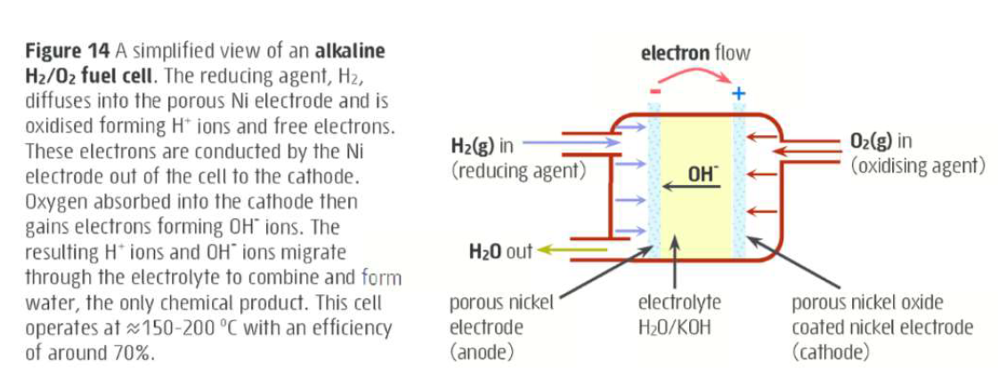

## Mistakes

* Always flip E0 value when reverse reaction
* Electrochemical cell => Anode is -ve, cathode positive, electrolytic => anode +ve, cathode -ve
* ALWAYS LOOK FOR H2O IN ELECTROLYTIC CELLS
* **REFER TO SPONTANEITY**
* **ENSURE RHS PROPERTIES = LHS PROPERTIES IN CHEMICAL EQUATION**
* **ANOX => ANODE OXIDISED**
* Include equations in explaining answers where possible
* Concentration effect => Redox potentials are only reliable for 1M concentrations
* DON’T ignore anion
* Use word => DISPORPORTIONATE
* SOLID ISN’T NECESSARILY FORMED IN GALVANIC CELL (at cathode) => ion formed can be aqueous => therefore, solid doesn’t necessarily gain mass
* Ions already within salt bridge move => use KNO3- for salt bridge salt